**Project Design Phase-II**

**Data Flow Diagram & User Stories**

|  |  |
| --- | --- |
| Date | 26-06-2025 |
| Team ID | LTVIP2025TMID59501 |
| Project Name | ResolveNow |
| Maximum Marks | 4 Marks |

**Data Flow Diagrams:**

A **Data Flow Diagram (DFD)** illustrates how data moves within the Freelance Finder platform. It captures how users (freelancers and clients) interact with the system, how information flows between different components, and where the data is stored.

Example: DFD Level 0 (Industry Standard)

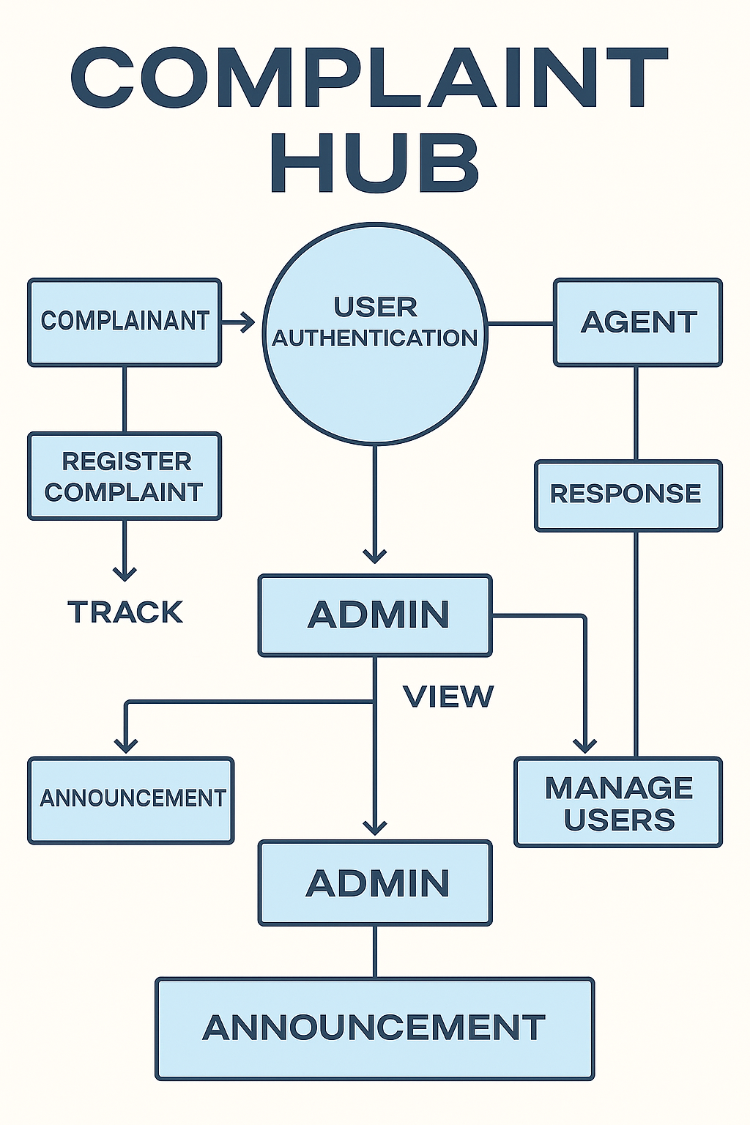

**User Stories**

**User Story Table – ResolveNow**

|  |  |  |  |  |  |
| --- | --- | --- | --- | --- | --- |
| **User Type** | **Functional Requirement (Epic)** | **User Story / Task** | **Acceptance Criteria** | **Priority** | **Release** |
| |  | | --- | | **Citizen** |  |  | | --- | |  | | |  | | --- | | Appointment Booking | | As a citizen, I can file a complaint with details like category, location, and photos. | Complaint is recorded and confirmation is shown | High | Sprint-1 |
| Citizen | Complaint Tracking | As a citizen, I can view the real-time status of my submitted complaints. | |  | | --- | | Status updates are visible with timestamps. |  |  | | --- | |  | | High | Sprint-2 |
| |  | | --- | | **Agent** |  |  | | --- | |  | | |  | | --- | | Complaint Resolution |  |  | | --- | |  |  |  | | --- | |  | | |  | | --- | | As an agent, I can view and update complaints assigned to me. |  |  |  | | --- | --- | | |  | | --- | |  | | | |  | | --- | | Complaint status is updated and reflected in user's dashboard. |  |  | | --- | |  | | High | Sprint-1 |
| **User** | In-app Messaging | As a user, I can chat with the other party in real-time. | Messages appear instantly. | Medium | Sprint-2 |
| **Admin** | User Management | As an admin, I can view and manage registered users. | Admin can suspend, delete, or update user accounts | High | Sprint |
| **Citizen** | Feedback and Ratings | As a citizen, I can give feedback after complaint resolution. | Review and rating appears on agent’s profile or admin view. | Medium | Sprint-2 |
| **user** | Escalation Management | As an admin, I can escalate unresolved or delayed complaints. | Escalation is recorded, and reassigned complaint gets high priority | High | Sprint-2 |
| **Admin** | Notifications | As a system, I send email/SMS notifications on complaint status updates. | Notifications are received by users when complaint status changes. | Medium | Sprint-2 |

|  |
| --- |
|  |